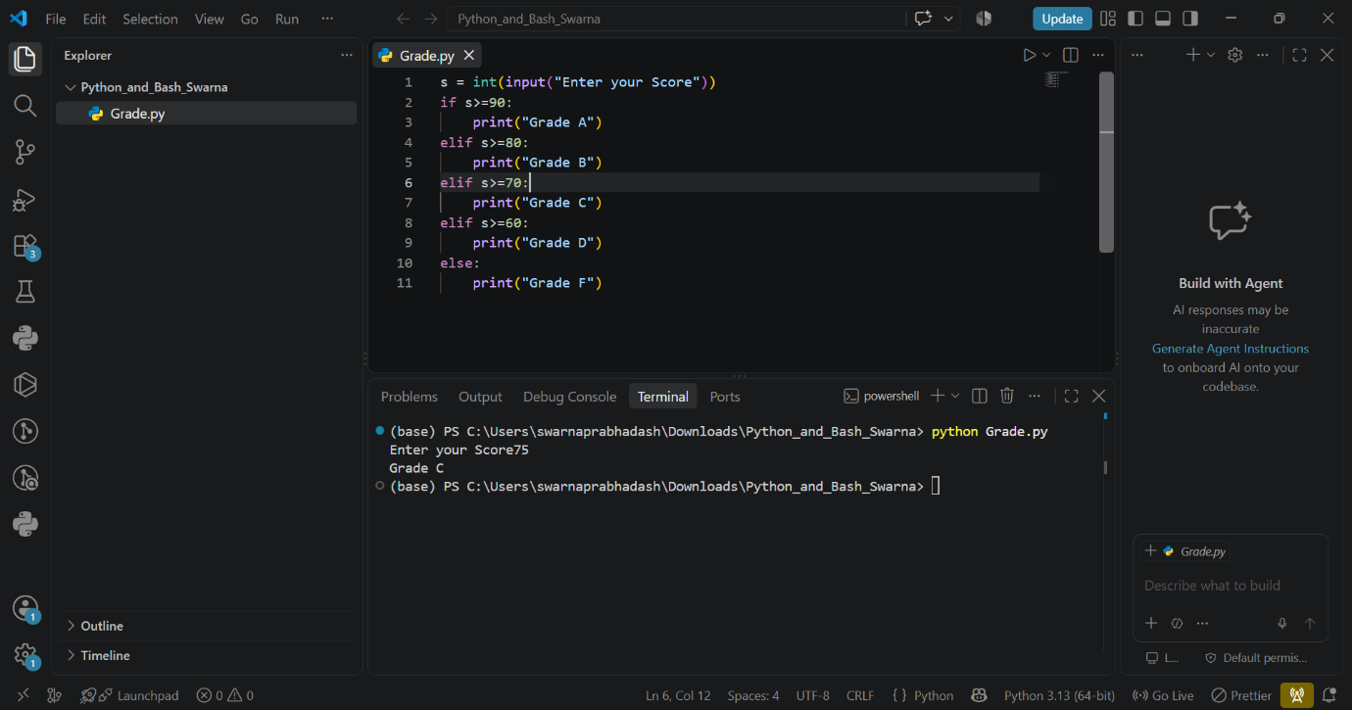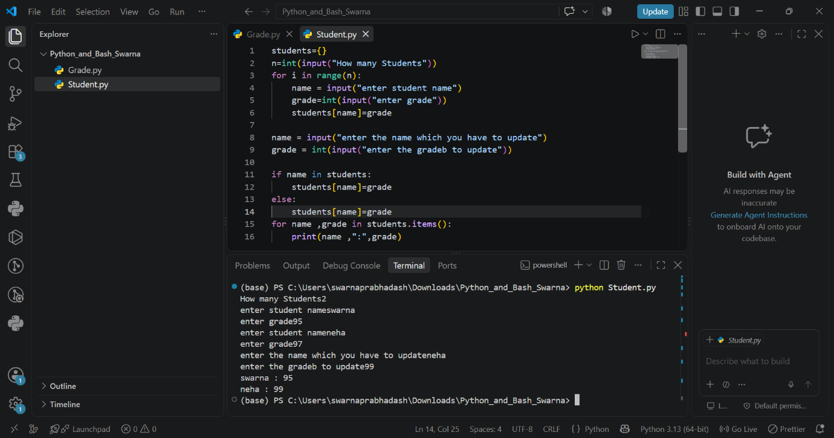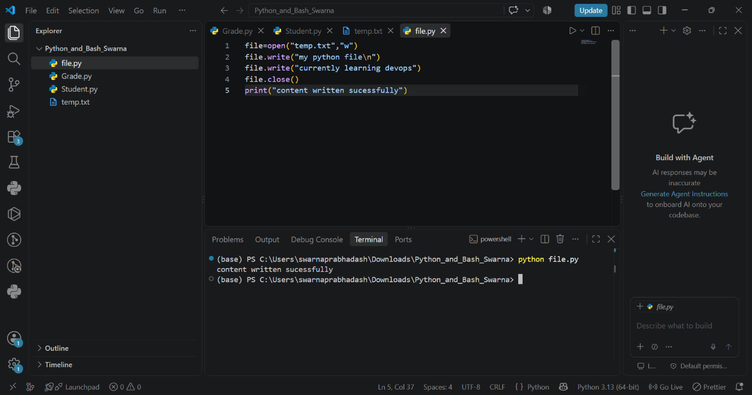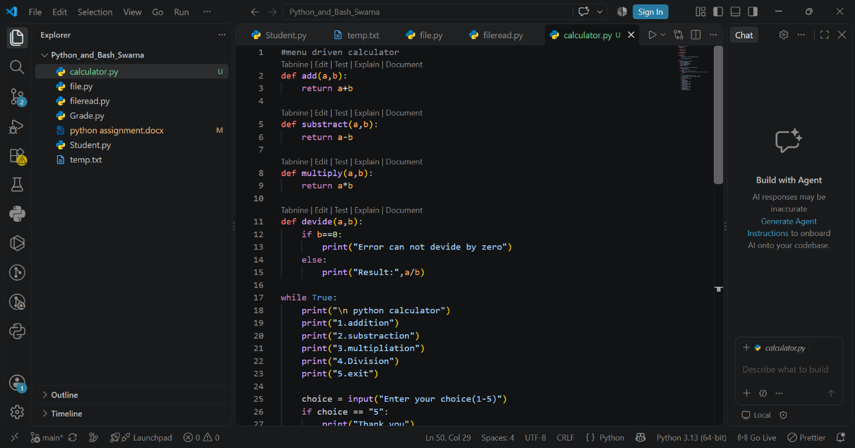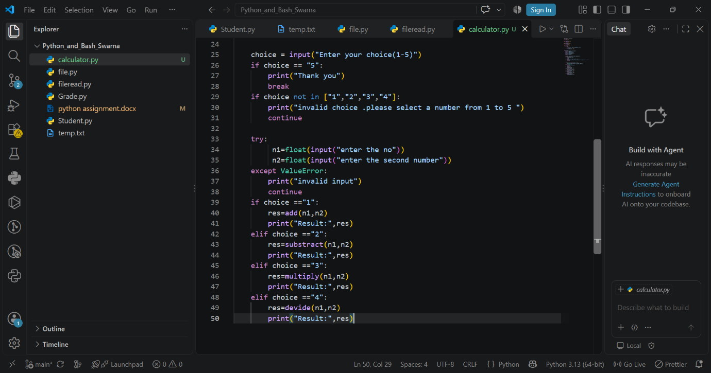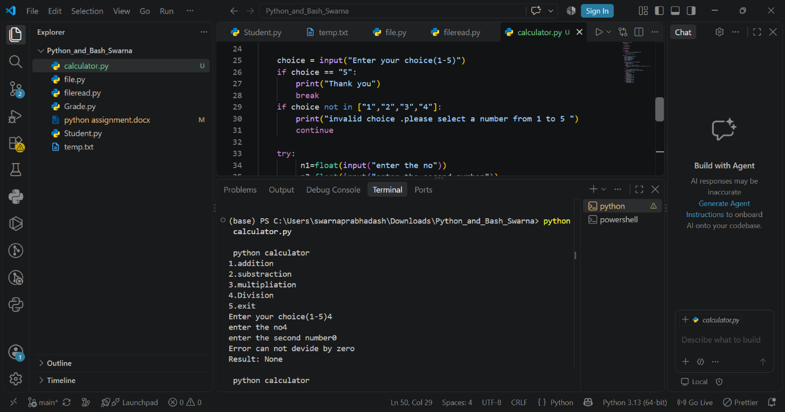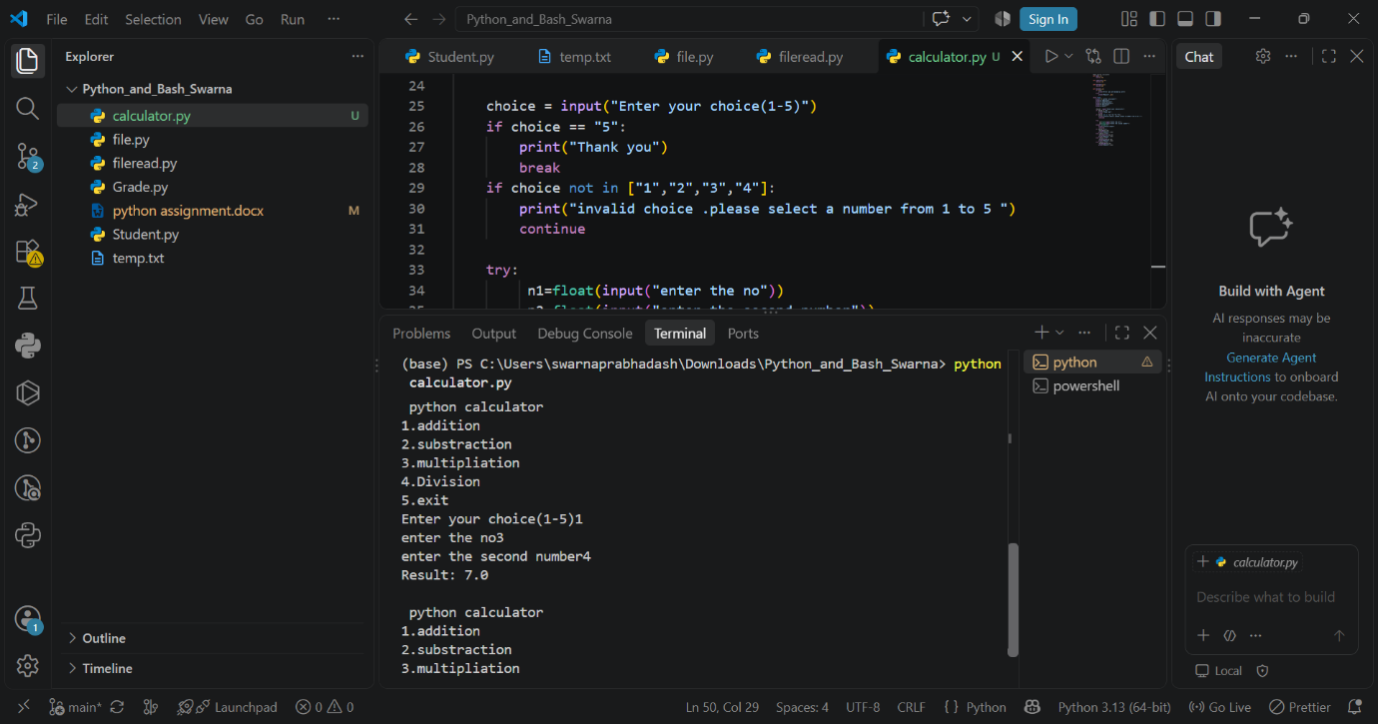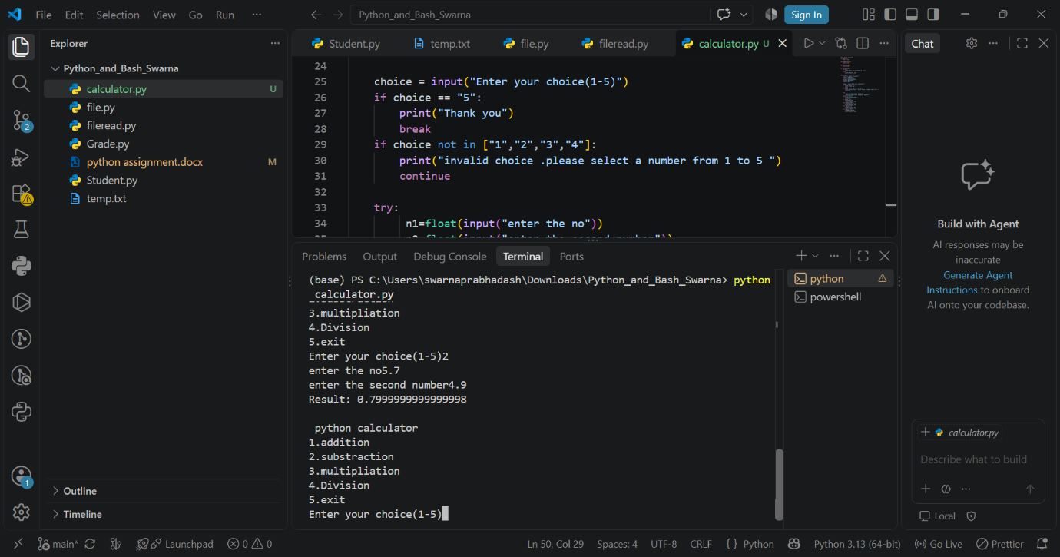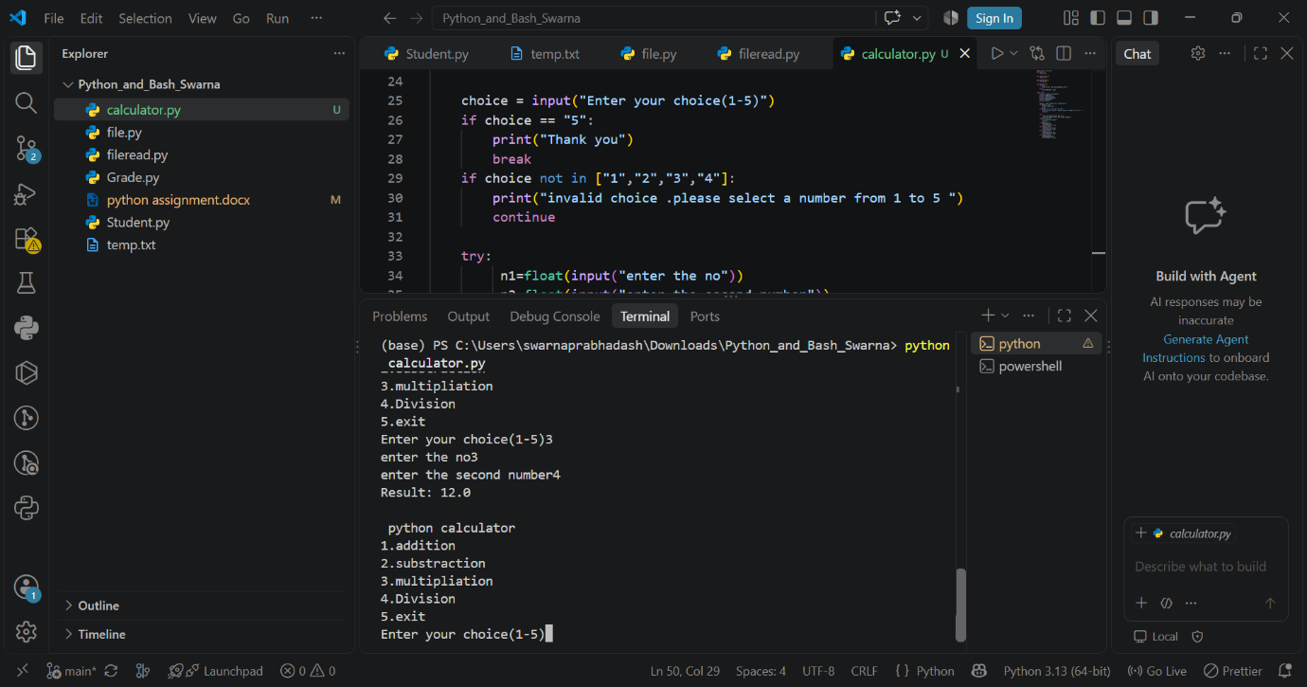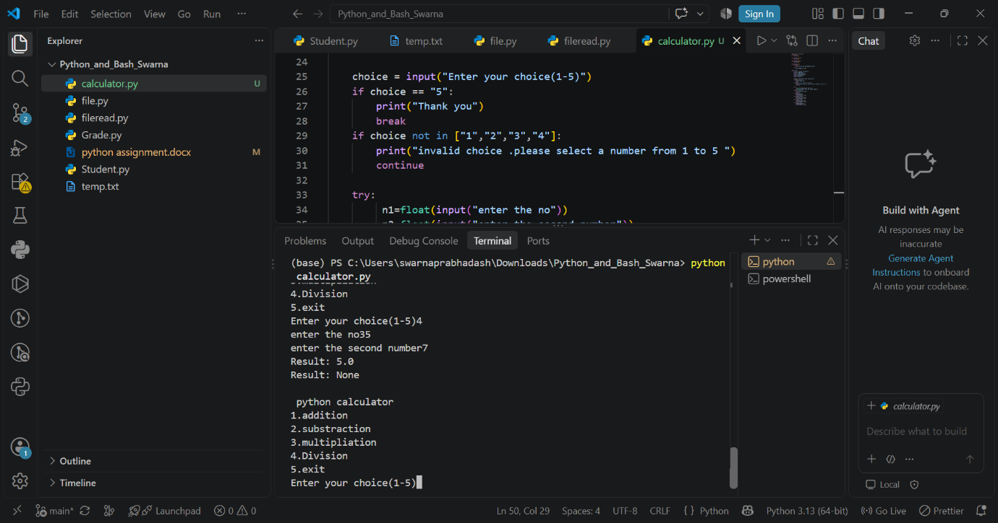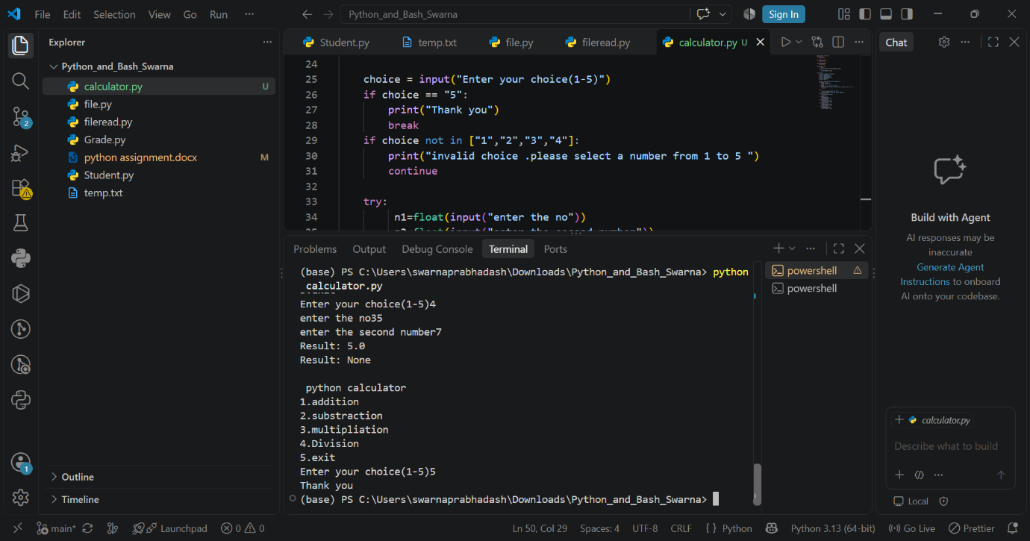

SOURCE CODE
1.
s = int(input("Enter your Score"))
if s>=90:
print("Grade A")
elif s>=80:
print("Grade B")
elif s>=70:
print("Grade C")
elif s>=60:
print("Grade D")
else:
print("Grade F")

2.
students={}
n=int(input("How many Students"))
for i in range(n):
name = input("enter student name")
grade=int(input("enter grade"))
students[name]=grade

name = input("enter the name which you have to update")
grade = int(input("enter the gradeb to update"))

if name in students:
students[name]=grade
else:
students[name]=grade
for name ,grade in students.items():
print(name ,":",grade)
3.
file=open("temp.txt","w")
file.write("my python file\n")
file.write("currently learning devops")
file.close()
print("content written sucessfully")
4.
file =open("temp.txt","r")
content = file.read()
print("file content")
print(content)
file.close()
5. #menu driven calculator
def add(a,b):
return a+b

def substract(a,b):
return a-b

def multiply(a,b):
return a*b

def devide(a,b):
if b==0:
print("Error can not devide by zero")
else:
print("Result:",a/b)

while True:
print("\n python calculator")
print("1.addition")
print("2.substraction")
print("3.multipliation")
print("4.Division")
print("5.exit")

choice = input("Enter your choice(1-5)")
if choice == "5":
print("Thank you")
break
if choice not in ["1","2","3","4"]:
print("invalid choice .please select a number from 1 to 5 ")
continue

try:
n1=float(input("enter the no"))
n2=float(input("enter the second number"))
except ValueError:
print("invalid input")
continue
if choice =="1":
res=add(n1,n2)
print("Result:",res)
elif choice =="2":
res=substract(n1,n2)
print("Result:",res)
elif choice =="3":
res=multiply(n1,n2)
print("Result:",res)
elif choice =="4":
res=devide(n1,n2)
print("Result:",res)

github repo link -https://github.com/swarna3009/-Python_and_Bash_Swarna.git

